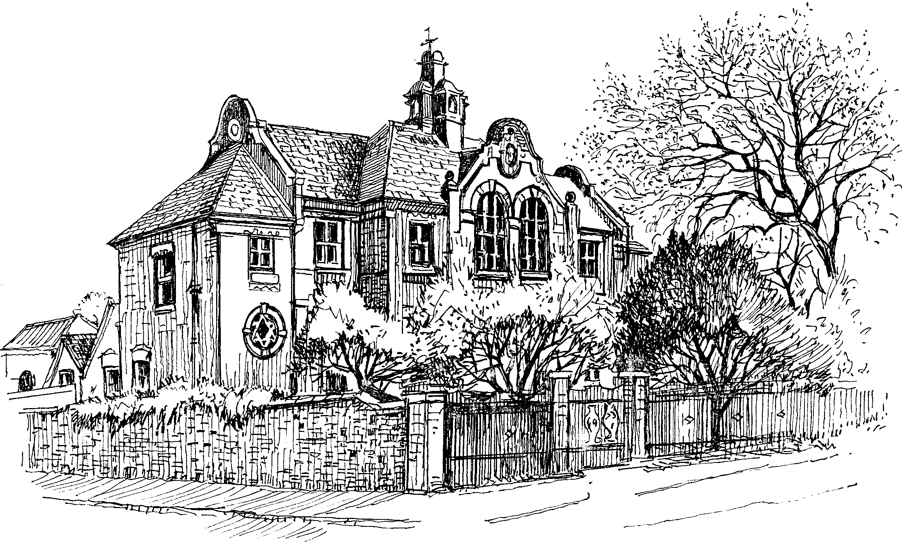
St. Edward's C of E Primary School
Dovecote
Castle Donington
Derby

DE74 2LH

Telephone & Facsimile: 01332 810231

office@stedwards-cd.leics.sch.uk
www.stedwards-cd.leics.sch.uk
Our vision is to be fruitful in all that we do
Headteacher: Mrs. Rachel Lacey

Leave of Absence Request

EXCEPTIONAL CIRCUMSTANCE APPLICATION FORM

Date of Application ……………………………………….

Name of child(ren) ……………………………………………………………………………………………………………….

First day of absence ………………........................................

Last day of absence……………………………………………………….

Names of both parents/carers …………………………………………………………............................

EXCEPTIONAL CIRCUMSTANCE FOR LEAVE OF ABSENCE REQUEST
Please provide full details for the reasons for this request. (Please attach additional information if required)

…………………………………………………………………………………………………………………………………………………………………….

…………………………………………………………………………………………………………………………………………………………………….

…………………………………………………………………………………………………………………………………………………………………….

…………………………………………………………………………………………………………………………………………………………………….

…………………………………………………………………………………………………………………………………………………………………….

…………………………………………………………………………………………………………………………………………………………………….

…………………………………………………………………………………………………………………………………………………………………….

…………………………………………………………………………………………………………………………………………………………………….

…………………………………………………………………………………………………………………………………………………………………….

…………………………………………………………………………………………………………………………………………………………………….

…………………………………………………………………………………………………………………………………………………………………….

…………………………………………………………………………………………………………………………………………………………………..

…………………………………………………………………………………………………………………………………………………………………..

…………………………………………………………………………………………………………………………………………………………………..

…………………………………………………………………………………………………………………………………………………………………..

………………………………………………………………………………………………………………………………………….........................

………………………………………………………………………………………………………………………………………………………………….

………………………………………………………………………………………………………………………………………………………………….

Please note under the government’s guidelines it is at the headteacher’s discretion as to whether this request is accepted or declined. If granted and your child does not return to school on the stated date, the school can remove your child off the school roll and you will be required to make a new application to the Local Authority for a school place. Government guidelines, which came into effect on 1st September 2013, prevent headteachers from granting any leave of absence during term time, unless there are exceptional circumstances. A family holiday during term-time does not fall under the category of ‘exceptional circumstances’.

Parents taking their child out of school where the request has been declined, leave themselves at risk of a penalty notice and/or prosecution. For an unauthorised leave of absence from August 2024, a penalty notice may be issued to both parents. These are charged at £160 per parent per child (discounted to £80 if paid within 21 days).

If there is occasion to issue a second Penalty Notice for an unauthorised leave of absence within a rolling 3-year period, it will be issued at the higher rate of £160 per parent per child, with no opportunity to pay at the lower level.

A Penalty Notice cannot be issued if there is a third occasion of unauthorised leave of absence in the rolling 3-year period and it is highly likely that the local authority will take direct prosecution action in the Magistrates’ Court.

Parent/carer’s signature …………………………………………………………… Date……………………………………………………..

Accepted DATE ………………...............

Declined DATE……………………………….

Headteacher ……………………………………………………………………………………………………………………………………

